MEDIA KIT
Hopping Off on a Business Trip
By Dr. Shellie Hipsky
Illustrated by Alyssa Nevin Hipsky
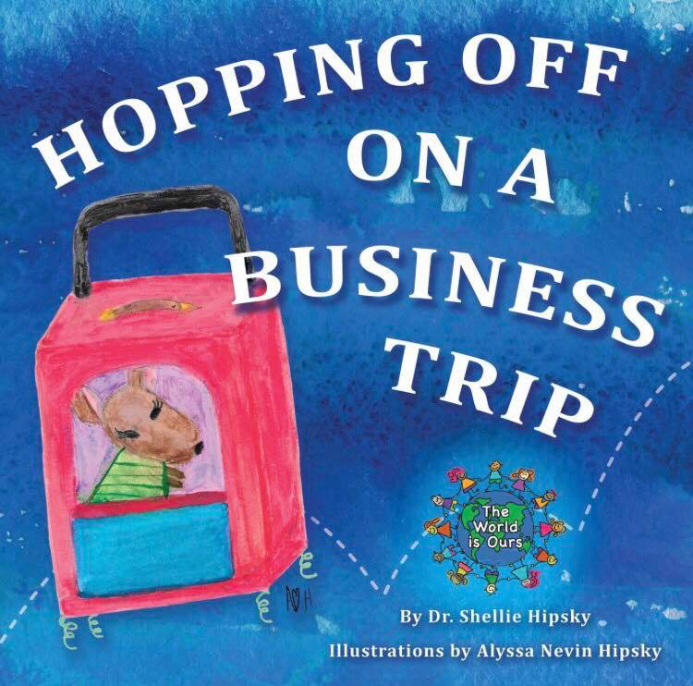

Contents:
Press Release, Key Words, Full Description, Short Description, About the Author, About the Illustrator, Full Bio, Reviews

Contact: Kelly Frost, VP of Inspiring Lives International
Phone: 412-335-8939
Dec. 13, 2016
FOR IMMEDIATE RELEASE

New Children’s Book Helps Comfort when Mommies Hop off on a Business Trip
Dr. Shellie Hipsky, editor-in-chief of Inspiring Lives Magazine and president of the Global Sisterhood non-profit, released her first children’s book Hopping Off on a Business Trip on December 13, 2016.
The book was inspired by her own struggle to help her children understand that when she had to speak at a conference out of town, she was thinking about them and coming back as soon as possible. Using a family of kangaroos based on her own family, Dr. Hipsky lets the child kangaroos express their feelings about Mommy being gone, as well as their coping mechanisms.
“I wanted to develop a fun book that encouraged children to use their imaginations to cope with their moms leaving for a couple days,” Dr. Hipsky said. She did just that. Sister kangaroo Savannah explains to her brother Cecil that she imagines herself traveling with Mommy on all her adventures. When Grandma (GrandRoo) makes a special surprise to help Cecil, Dr. Hipsky’s work demonstrates the ability of a family to come together to solve a problem.
Dr. Hipsky takes this idea to heart, having her own daughter, Alyssa Nevin Hipsky, illustrate the book. At just 9 years old, Alyssa did an internship with artist Kathleen Belskey to hone her artistic talents and develop the illustrations for the book cover and interior.
“It has been my dream to collaborate with her on a big project,” Dr. Hipsky said. “Alyssa always helped with my fundraisers when I did shows for the Homeless Children’s Education Fund, and even this year, she modeled for Fly Tots—a children’s line from California—at the Inspiring Lives Magazine Launch Party. Asking her to illustrate my first children’s book—as well as the rest of the books in the series to come—is just another step for us to bond while creating together.”
The World is Ours book series starts with Hopping off on a Business Trip and will continue with other books that help children understand situations in their daily lives. Dr. Hipsky plans to take children around the world with these books, featuring animals from a different continent—as well as fun facts about them—in each.
Hopping off on a Business Trip is available on Amazon.com and barnsandnoble.com, as well as at most major bookstores. Dr. Hipsky and Alyssa’s first book signing will be December 23 at 2 pm at the Pittsburgh (Pa.) Children's Museum. A portion of the proceeds from the series’ book sales will go to the Global Sisterhood, which donates to multiple charities that focus on the care and education of women and children.

Keywords
children's book, juvenile fiction, business trip, working parents, Alyssa Hipsky, Shellie Hipsky, grandparents, New York, Great Wall of China, Eiffel Tower, child illustrator, mommypreneuer,

Full Description
Kangaroo kids Savannah is concerned that her little brother Cecil is acting differently. He misses their mom, who is away on business. Can GrandRoo help Savannah make Cecil feel better while they wait for their mom to hop back home to her loving family? Enjoy this first book in The World Is Ours books series, which is written by International best Selling Author Dr. Shellie Hipsky and illustrated by her 9-year-old daughter Alyssa Nevin Hipsky.

Short Description
Enjoy this first book in The World Is Ours books series, Hopping Off on a Business Trip, which is written by Dr. Shellie Hipsky and illustrated by her 9-year-old daughter Alyssa Nevin Hipsky. This is book about a kangaroo family is the perfect book to explain to a child when their parent needs to go to work.

About the Author: Dr. Shellie Hipsky
Dr. Shellie Hipsky is the author of ten non-fiction books for adults, some of which have become international best sellers. After being an education professor for a decade, she founded the non-profit charity the Global Sisterhood (www.Global SisterhoodOnline.org), which provides resources to help women live out their dreams and connect with each other. Through her company Inspiring Lives International, she does public speaking, hosts TV and radio shows, and empowers others. She is delighted to work with her talented daughter Alyssa Hipsky on this children’s book series that supports the Next Generation Global Sisterhood!

About the Illustrator: Alyssa Nevin Hipsky
Alyssa Nevin Hipsky is a 9-year-old illustrator who hopped at the opportunity to work with her mom on her first published children’s book! She is the apprentice for master artist Kat Belskey of the Mosaic K Studio. Alyssa loves gymnastics, horseback riding, science, and the arts. She plans on running a science company when she is older. She loves to travel with her mom on business trips. Alyssa is a founder of the Next Generation Global Sisterhood, which is a volunteering organization that gives girls the opportunity to help others in need.
Watch for their next book Princess Pride with Purpose in The World is Ours book series!
Dr. Shellie Hipsky: Full Bio
Dr. Shellie Hipsky inspires, educates, and entertains internationally. With opulent photography gracing the pages, each issue of Inspiring Lives Magazine (offers captivating stories and empowering ideas imprinted with Dr. Shellie Hipsky’s vision on business and finance, art and film, books, music, health and wellness, relationships and self-discovery, fashion and beauty, food, and travel.
Emphasizing entrepreneurship and personal growth, this magazine inspires, encourages, and instructs, addressing every facet of a woman’s life.
Dr. Shellie is the Executive Director of the new non-profit 501 (c) (3) the Global Sisterhood which guides and supports women and girls towards their dreams and goals.

She was deemed “Inspirational Woman of the Month” in Inspirational Woman Magazine and a “Luminary Author” for Inspire Me Today. She earned “Entrepreneur of the Year in Inspiration and Empowerment” and “VIP Woman of the Year”, she was also, one of the “2015 National Professional Woman’s Association’s Women of the Year” and in she was named the 2013 “Best Business Woman in Pittsburgh” Women’s Small Business Association for her Inspiring Lives, LLC and her TV show Inspiring Lives with Dr. Shellie.

Dr. Shellie Hipsky is affiliated with the following organizations: the National Association for Professional Women, Women’s Small Business Association, Coterie. She also serves on the Advisory Boards of the National Association for Women Business Owners, the Homeless Children’s Education Fund, and the World Heritage Cultural Center.

As a former professor of the Global Perspective at the Ph.D. Level for over a decade she is a proven expert on what she teaches. She keynotes events around the globe. The latest of her 10 published books, the internationally best selling Common Threads trilogy, provides Inspiration, Empowerment, and Balance based on 100 amazing interviews from her Empowering Women Radio.

She is delighted to work with her talented daughter Alyssa Hipsky on this The World is Ours children’s book series that supports the Next Generation Global Sisterhood!

Reviews

"This book is a sweet and comforting must-have for mommypreneurs!" - Cori Wamsley, Platform Magazine
"Every child of working parent should have this delightfully comforting book on their shelf." - Kelly Frost, Author of A Toast to Motherhood
"This book addresses and embraces the concerns and perspectives of children dealing with a busy Mom-on-the-go! Hop on over for a refreshing and effective solution to helping children problem-solve a challenging situation." - Donna Davis, Inspiring Lives Magazine
Social Media Posts for Hopping Off on a Business Trip

Thank you for helping us spread the word about Hopping Off on a Business Trip! These are super easy to cut and paste into social media. To help us spread the word on the Book Launch date Dec. 13th and beyond! Alyssa and I thank you so much!

FACEBOOK/LINKED IN

Enjoy this first book in The World Is Ours books series, Hopping Off on a Business Trip which is illustrated by 9-year-old artist Alyssa Nevin Hipsky. This is book about a kangaroo family is the perfect book to explain to a child when their parent needs to go to work. #TheWorldIsOurs #InspiringLives #HoppingOff

I am thrilled for my friend Dr. Shellie Hipsky who is publishing her first children’s book (she has authored 11 books). Her 9 year old daughter Alyssa illustrated it and it explains to children that even though parents may have to go away to work, they will come back… they are always in their parent’s hearts. Get this book for a child in your life for the holidays! #TheWorldIsOurs #InspiringLives #HoppingOff

The Global Sisterhood is proud of our #NextGenGlobalSisterhood doing amazing things such as been young entrepreneurs, talented performers, and now published illustrators. Alyssa is 9 years old and she illustrated Hopping Off on a Buisness Trip. Get a copy for the child you love today! #TheWorldIsOurs #InspiringLives #HoppingOff

TWEETS
9 yr old illustrator shows children that may parents go Hopping Off on a Business trip, but they come back! #TheWorldIsOurs #InspiringLives #HoppingOff

Hopping Off on a Business Trip explains to a child about parents needing to go to work. #TheWorldIsOurs #InspiringLives #HoppingOff

Read with your child Hopping Off on a Business Trip! Illustrated by a 9 year old. #TheWorldIsOurs #InspiringLives #HoppingOff

Working parents need Hopping Off on a Business Trip on their children’s bookshelves! #TheWorldIsOurs #InspiringLives #HoppingOff

Dr. Shellie Hipsky #Mommypreneur who wrote Hopping Off on a Business Trip to help kids. Get yours a copy! #TheWorldIsOurs #InspiringLives #HoppingOff

